

CAREER FORGE

PROJECT SUPERVISOR
Ms. Rubab Jaffar

PROJECT TEAM
Syed Muhammad Ammar Hyder | 22K-4816
Muhammad Ausaja Hussain | 22K-5186
Muhammad Abdullah | 22K-5156

Submitted in partial fulfillment of the requirements for the degree of Bachelor of Science in Software Engineering.

FAST SCHOOL OF COMPUTING
NATIONAL UNIVERSITY OF COMPUTER AND EMERGING SCIENCES KARACHI CAMPUS
Spring 2026

Project Supervisor | Ms. Rubab Jaffar
Project Team | Syed Muhammad Ammar Hyder K22-4816  Muhammad Ausaja Hussain K22-5186  Muhammad Abdullah K22-5156
Submission Date | 10th May 2026

Ms. Rubab Jaffar

Supervisor

FAST SCHOOL OF COMPUTING
NATIONAL UNIVERSITY OF COMPUTER AND EMERGING SCIENCES KARACHI CAMPUS

I. Abstract
CareerForge is an AI-powered recruitment platform designed specifically for the Computer Science and Information Technology job market. Traditional job portals often rely on keyword-based matching, manual screening, and unverified job postings, which can result in irrelevant candidate-job matches, inefficient hiring decisions, biased job descriptions, and reduced trust among applicants and employers. These issues are especially important for fresh graduates and early-career professionals, who often need clearer career guidance, skill-gap awareness, and a more structured application process.
CareerForge addresses these challenges by combining a modern recruitment portal with AI-assisted modules for fraud detection, job-description enhancement, candidate-job matching, and multi-stage candidate screening. Candidates can create profiles, upload resumes, explore suitable jobs, apply through an interactive flow, and complete assessments such as MCQ tests, technical evaluations, and AI-assisted interviews. Employers can create job postings, improve job descriptions, view ranked applicants, and evaluate candidate performance through stored assessment results. Administrators support trust and moderation by reviewing suspicious jobs and managing system users.
The system is implemented as a web-based application using React.js and Tailwind CSS for the frontend, FastAPI for backend services, Supabase for authentication, structured database storage and file storage, and Pinecone for vector-based semantic search. The updated database schema supports applications, resumes, saved jobs, fraud reports, screening tests, test attempts, MCQ responses, technical submissions, interview transcripts, and notifications. Through this integrated design, CareerForge aims to provide a reliable, efficient, and intelligent recruitment ecosystem for the Pakistani CS/IT hiring domain.

II. Contents
I. Abstract 3
II. Contents 4
1. Introduction 6
1.1 Problem Statement 6
1.2 Proposed Solution 6
1.3 Project Overview 7
2. Related Work 7
3. Requirements 9
3.1 Functional Requirements 9
3.2 Non-Functional Requirements 9
3.3 Stakeholders 10
3.4 Operating Environment 10
3.5 System Constraints 11
3.6 Assumptions and Dependencies 11
3.7 System Functional Hierarchy 11
4. Design 13
4.1 System Architecture 13
4.2 Database Design 14
4.3 Design Assumptions 16
4.4 Design Dependencies 17
4.5 Risk 17
4.6 Volatile Areas 17
4.7 Risk Mitigation Approaches 18
4.8 System Level Architecture 18
4.8.1 High-level Subsystems 18
4.8.2 System Elements Relationships 19
4.8.3 External System Interface 19
4.9 Lifecycle Visualization (State Diagram) 20
4.9.1 Job Posting Lifecycle 20
4.9.2 Application Lifecycle 21
4.9.3 Assessment Lifecycle 22
4.9.4 Interview Lifecycle 23
4.10 Workflow Visualizations (Sequence Diagram) 24
4.10.1 Authentication Workflow 24
4.10.2 Resume Parsing Workflow 24
4.10.3 Job Application Workflow 25
4.10.4 Candidate Ranking Workflow 25
4.10.5 AI Interview Workflow 26
4.10.6 Fraud Detection Workflow 26
5. Implementation 27
5.1 FYP-I Implementation 27
5.2 FYP-II Implementation 27
6. Testing and Evaluation 29
7. Conclusion 30
8. Generative AI Usage Statement 31
9. References 32

1. Introduction

1.1 Problem Statement
The recruitment process in Pakistan’s IT and computer science sector faces several persistent problems. Existing job portals often produce irrelevant results because they depend heavily on keyword-based search rather than semantic understanding of a candidate’s actual skills and job requirements. Candidates, especially fresh graduates, may apply to many jobs without knowing whether their profile matches the role or which skills they need to improve. At the same time, employers receive large volumes of applications and must manually filter resumes, which makes screening slow, inconsistent, and prone to human bias.
Another major issue is trust. Fraudulent or suspicious job postings reduce confidence in online recruitment platforms, while vague or biased job descriptions can discourage suitable applicants. Employers also need better tools to evaluate technical ability before shortlisting candidates. Without a structured screening pipeline, it becomes difficult to compare applicants fairly across MCQ knowledge checks, technical answers, coding ability, and interview responses.
CareerForge is designed to address these problems within the CS/IT recruitment domain by using AI-supported fraud detection, resume parsing, semantic job matching, job-description enhancement, and candidate screening modules. The goal is not only to create a job portal, but to provide a trustworthy and intelligent pre-hiring system that supports candidates, employers, and administrators.

1.2 Proposed Solution
CareerForge provides a specialized AI-powered recruitment platform for CS and IT roles. The system allows candidates to create profiles, upload resumes, view suitable job opportunities, save jobs, apply to selected postings, and complete assigned screening stages. Resume data is parsed into structured candidate information and can be used for matching, recommendation, and skill-gap analysis. The platform also supports an interactive application experience through swipe-to-apply and advanced search features.
For employers, CareerForge provides tools to create and manage job postings, enhance job descriptions, view applications, and assess candidates through a multi-stage screening pipeline. This pipeline includes MCQ assessments, technical questions or coding-style submissions, and AI-assisted interview evaluation. Assessment attempts, grading outputs, rubrics, feedback, and transcripts are stored in the database so employers can review candidate performance in a structured way.
For administrators, the system includes moderation and reporting support. Suspicious jobs can be flagged using AI-generated fraud scores or user reports. Admins can review reports, manage users, and help maintain platform integrity. Together, these features create a recruitment ecosystem that is more reliable, transparent, and efficient than a traditional job-board-only approach.

1.3 Project Overview
CareerForge is a web-based system built around three primary user roles: Candidate, Employer, and Admin. The frontend is developed using React.js and Tailwind CSS, while the backend is implemented using FastAPI. Supabase is used for authentication, PostgreSQL-based structured data, and resume storage. Pinecone supports vector-based semantic search and candidate-job matching. External AI services support tasks such as resume parsing, job-description enhancement, assessment generation, technical evaluation, and interview response scoring.
The system follows a modular design so that recruitment features, AI services, assessment workflows, moderation, and notifications can be developed and tested independently. This makes the system easier to extend while keeping the core workflow clear: an employer posts a job, a candidate applies, the application record is created, screening stages are generated or assigned, the candidate completes assessments, results are stored, and the employer reviews the candidate’s performance.

2. Related Work
Existing job portals such as LinkedIn, Indeed, and Rozee.pk are widely used for job searching, hiring, company profiles, and online application submission [1]–[3]. These platforms provide large-scale recruitment access for both employers and job seekers. However, they are generally designed for broad recruitment coverage and commonly depend on keyword-based search, filters, and manual screening. In specialized Computer Science and Information Technology hiring, keyword matching alone may not fully capture the relationship between technical skills, tools, project experience, and job requirements. Moreover, these portals do not provide a complete built-in candidate screening pipeline that includes MCQ assessments, technical tests, and AI-assisted interview evaluation within the same recruitment workflow. This can result in irrelevant job recommendations for candidates and inefficient applicant shortlisting for employers.
Research in recruitment technology shows that artificial intelligence and natural language processing can improve resume parsing, candidate ranking, and job–resume matching. Studies on job–resume matching have applied natural language processing and deep learning techniques to compute semantic similarity between job descriptions and candidate resumes, producing more meaningful relevance scores than traditional keyword matching [4]. This indicates that semantic analysis can provide better support for recruitment systems where skills and experience need to be interpreted contextually rather than matched through exact words.
Fraud detection is another important area in online recruitment. Machine learning and NLP techniques have been applied to detect fake job postings by analyzing patterns in job descriptions and related posting information [5]. This is significant because fraudulent or misleading job posts reduce trust in recruitment platforms and can expose job seekers to risk. Existing job portals may provide reporting or moderation mechanisms, but automated fraud detection remains an important research direction for improving safety and reliability in online hiring systems.
Fairness and clarity in job descriptions have also been studied in recruitment research. Gaucher et al. showed that job advertisements may contain gendered wording that can discourage diverse applicants and contribute to inequality in hiring contexts [6]. This highlights the importance of using language-aware systems to improve job descriptions by reducing biased wording, increasing clarity, and making job posts more inclusive.
Recent AI and web technologies further support the development of intelligent recruitment platforms. Generative AI tools can assist in text generation and evaluation tasks [7], search-based APIs can retrieve relevant technical context [8], WebRTC can support real-time communication features [9], FastAPI can be used for scalable backend API development [10], Supabase can support authentication and database management [11], and vector databases such as Pinecone can enable semantic search and similarity matching [12].
Overall, existing platforms and research show progress in job search, resume matching, fraud detection, bias reduction, and intelligent recruitment support. However, these capabilities are often studied or implemented separately, and commonly used job portals do not provide a unified built-in screening workflow for MCQs, technical assessment, and AI-assisted interview evaluation. This creates a gap for a specialized recruitment platform that combines trust, semantic matching, fair job descriptions, and structured candidate evaluation within the CS/IT hiring domain.

3. Requirements
The system is limited to CS/IT recruitment and focuses on the pre-hiring process. Post-hiring HR features such as payroll, onboarding, employee retention, and non-technical industry recruitment are outside the current scope.

3.1 Functional Requirements
The main functional requirements of CareerForge are as follows:
- Users can register and log in using role-based authentication for Candidates, Employers, and Admins.
- Candidates can create and update their profiles with education, skills, experience, projects, and personal summaries.
- Candidates can upload resumes in supported formats and the system can store and parse resume content.
- Candidates can search, filter, save, and apply to CS/IT job postings.
- Candidates can view job recommendations and skill-gap insights based on their profile and job requirements.
- Employers can create, edit, close, and manage job postings with required skills, salary range, location, job type, and experience level.
- The system can assign or create screening tests for job applications, including MCQ tests, technical questions, and AI-interview evaluation.
- Candidates can attempt MCQ assessments and submit responses for automatic grading.
- Candidates can submit technical answers or coding-style solutions that can be evaluated using AI-supported scoring and feedback.
- Interview audio or responses can be transcribed, stored, and evaluated for relevance, clarity, technical accuracy, and explanation depth.
- Employers can view applications, assessment scores, AI feedback, interview summaries, and candidate rankings.
- Users can report suspicious jobs and admins can review fraud reports and job status.
- The system can store notifications related to applications, assessment updates, and user-facing alerts.

3.2 Non-Functional Requirements
The non-functional requirements define the expected quality, security, and performance standards of the system:
- Performance: The platform should provide responsive interaction for common workflows such as login, job search, profile updates, and application submission.
- Security: Authentication and authorization must separate Candidate, Employer, and Admin access. Sensitive files such as resumes must be stored securely.
- Reliability: External AI service failures should not corrupt user data or break the entire application workflow.
- Scalability: The architecture should support future expansion through modular backend services, Supabase storage, and vector search integration.
- Usability: The interface should remain simple enough for students, fresh graduates, employers, and administrators to use without technical difficulty.
- Maintainability: The backend should use a clean modular structure with separate routes, controllers, services, middleware, and utility modules.

3.3 Stakeholders
- Candidates are allowed to upload their CVs, apply for jobs, attempt AI-based assessments (which includes mock-tests and AI-assisted interviews) and receive recommendations about where they lack in terms of skills
- Employers are allowed to post job openings/posts, view best ranked candidates for every specific job they posted, and conduct and review AI-assisted evaluations.
- Administrators are given master control of the system and are considered the authoritative figure, where they can manage individual users and their profiles, moderate job postings to check if there are no bogus jobs (as some are posted to collect data, or may be scam), and analyze fraud detection results.
- Development Team is responsible for implementing the system according to its requirements, ensuring the system works as intended and does not fail when needed, and is deployed to be used by the public.
- Supervisor is responsible for overseeing the progress of the project, making sure that the development team works according to the specifications, and ensuring that the system being developed has quality (in terms of efficiency, availability etc.)
- End Users are the tech companies, startups, and IT professionals who will utilize the system as it was made to be used.

3.4 Operating Environment
- Platform: Web-based application that is compatible with modern browsers such as Chrome, Edge, Firefox etc.
- Frontend: ReactJs with Tailwind CSS for responsive, component-based design
- Backend: FastAPI for high-performance RESTful APIs
- Database: Supabase (PostgreSQL-based) for storing structured data in tables; Pinecone for AI vector search
- AI Frameworks: Gemini API & RoBerta
- Operating System Compatibility: Windows, macOS, and Linux
- Internet Requirements: Stable connection required for API calls, AI services and real-time notifications

3.5 System Constraints
- The system relies on third-party APIs for certain functionalities such as JD enhancement, Test Generation, Career Guidance etc.
- Fraud detection efficiency depends upon the quality and quantity of training data
- Internet connectivity is mandatory for all AI-driven features and backend operations
- System scalability was limited by free-tier resource constraints during development
- Limited multilingual support (English–only interface)
- Data security and privacy must comply with general ethical and data protection standards

3.6 Assumptions and Dependencies
- Users are expected to provide accurate personal and professional information when creating accounts
- Employers will post legitimate and verified job openings
- The system depends upon Supabase and Pinecone for backend storage and AI indexing
- Notifications (email or in-app) depend upon third-party services such as Gmail.
- All stakeholders are expected to have reliable internet access and web browsers
- Ethical AI practices are followed to prevent algorithmic bias or unfair recommendations

3.7 System Functional Hierarchy
- User Management (for Adminstrator)
  - Create User Accounts
  - Delete Users
  - View All Users
  - Manage User Roles (Candidate/Employer/Admin)
- Candidate Functions
  - Candidate Registration & Login
  - Create & Update Profile
  - Upload and Parse Resume (CV)
  - View Job Recommendations
  - Search & Filter Jobs
  - Swipe-to-Apply (Apply / Reject)
  - Attempt MCQ Test
  - Attempt Coding Test
  - AI-Assessed Interview
  - View Skill-Gap Analysis
  - View Career Path Suggestions
  - View Application Status
  - Receive Notifications (email + in-app)
- Employer Functions
  - Register/Login
  - Create Job Posting
  - Edit or Close Job Posting
  - View Candidates Ranked by AI
  - Shortlist Candidates
  - Invite Candidates for Tests/Interviews
  - Manage Company Profile
  - Receive Notifications
- AI-driven Features
  - Fake Job Detection
  - Resume Parsing & Candidate Ranking
  - Job Description Enhancer (Clarity, Bias Removal)
  - Skill-Gap Analyzer
  - Career Path Recommender
  - Job Matching Engine
  - AI-Assessed Interview
- Job Search & Filtering
  - Search by Title
  - Search by Skills
  - Search by Experience Level
  - Search by Location
- Moderation & Reporting
  - User Reporting of Suspicious Job Posts
  - Admin Review of Reported Listings
  - Automated Flagging using AI Fraud Score
  - Remove or Suspend Fraudulent Employers
- Notifications
  - Application Status Updates
  - New Job Alerts
  - Employer Messages
  - System Announcements

4. Design

4.1 System Architecture
CareerForge follows a modular, layered, and service-oriented architecture. The frontend communicates with the FastAPI backend through RESTful APIs. The backend manages authentication-related workflows, job posting, application handling, resume processing, candidate screening, moderation, and communication with external services. Supabase provides authentication, PostgreSQL data storage, and file storage, while Pinecone stores and retrieves vector embeddings used for semantic matching and recommendations.
The system architecture separates user-facing interfaces from backend business logic and AI services. Candidates, employers, and admins interact through the frontend dashboards. Backend modules then connect to the appropriate data stores and AI services. This separation allows AI modules such as the resume parser, JD-CV matcher, fraud detector, JD enhancer, skill-gap analyzer, career recommendation engine, and AI interview assistant to operate as independent components while remaining connected to the overall recruitment workflow.
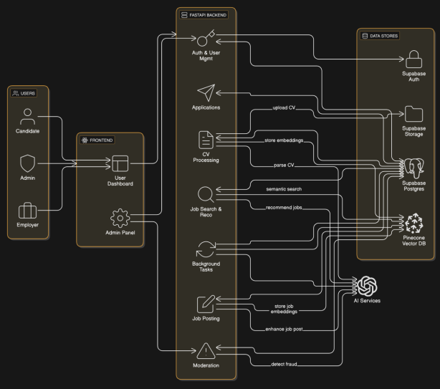
Figure 1: CareerForge System Architecture Diagram
The architecture shows Candidates, Employers, and Admins accessing the frontend, which routes requests to the FastAPI backend. The backend interacts with Supabase Auth, Supabase Storage, Supabase PostgreSQL, Pinecone Vector DB, and AI services. This supports the complete workflow from job posting and CV upload to semantic search, fraud detection, recommendation, and moderation.

4.2 Database Design
CareerForge uses a relational database design based on Supabase PostgreSQL. The database stores user profiles, candidate details, employer details, resumes, jobs, applications, saved jobs, fraud reports, screening tests, test attempts, schedules, MCQ questions and answers, technical questions and submissions, interview transcripts, and notifications. The updated schema extends the original SDS design by adding deeper support for FYP-II candidate screening and AI grading workflows.
The database separates base user identity from role-specific profiles. The profiles table stores common user information and role data, while candidate_profiles and employer_profiles store candidate-specific and employer-specific details. Jobs are linked to employer profiles, and applications connect candidates to jobs and resumes. Assessment data is organized around screening_tests, test_attempts, and related response tables so that MCQ answers, technical submissions, and interview transcripts remain tied to a specific candidate application.
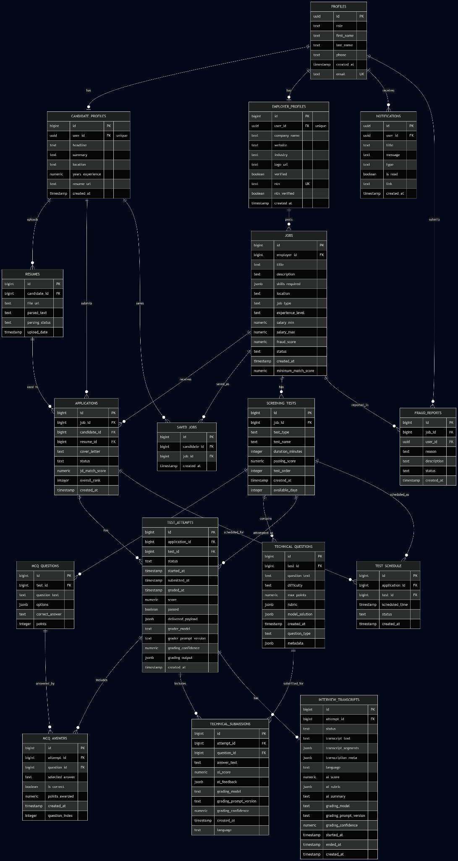
Figure 2: CareerForge Database Schema Diagram
The database schema diagram presents the actual table-level structure, including primary keys, foreign keys, and major columns. It is used to show the complete database design implemented for the final report, including the newer screening and evaluation tables.
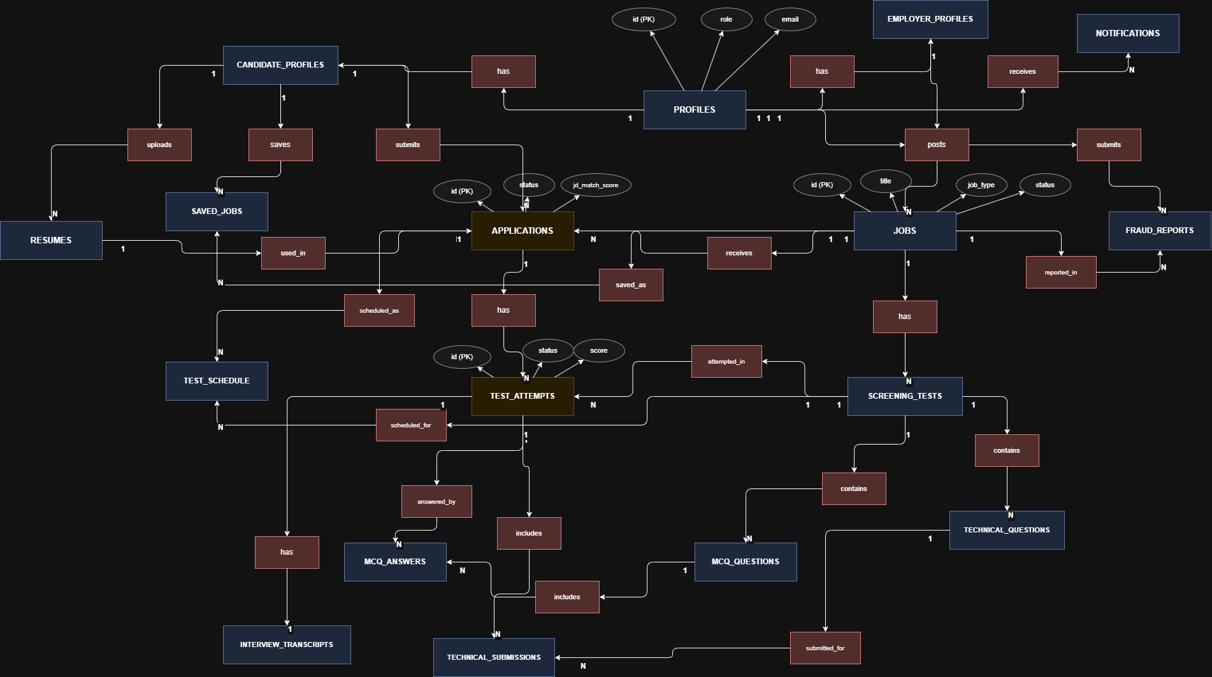
Figure 3: CareerForge Entity Relationship Diagram
The entity relationship diagram summarizes how the major tables are related. Profiles connect to candidate and employer profiles; employers post jobs; candidates upload resumes, save jobs, and submit applications; applications connect to test attempts and schedules; screening tests contain MCQ and technical questions; and test attempts connect to MCQ answers, technical submissions, and interview transcripts.

4.3 Design Assumptions
- The system will follow a modular and service-oriented architecture, where features like job matching, fraud detection, resume parsing, and vector search operate as independent services communicating through APIs
- AI services such as resume parsing, JD enhancement, career path recommendation etc., will rely on stable third-party APIs or pre-trained models ensuring minimal computational load on backend infrastructure
- All persistent data structures (including Users, Jobs, Applications, Test Results, Logs etc.,) will be stored in Supabase (PostgreSQL) and accessed via a well-defined Data Access Layer (DAL)
- System performance (such as searching, ranking, fraud detection etc.,) relies heavily on fast vector similarity search, assuming Pinceone will be accessible and operational
- The frontend and backend will interact exclusively via RESTful APIs secured with JWT tokens
- Authentication flows assume Supabase Auth will consistently handle email/password verification, session lifecycle, and access tokens
- Candidate assessments (MCQs, coding tests, AI interviews) assume predictable latency for external code execution and model inference

4.4 Design Dependencies
- Supabase used for user authentication, database storage, and file storage (CVs)
- FastAPI backend for managing business logic, integrating AI services, and exposing REST APIs
- Pinecone for storing and retrieving vector embeddings (job embeddings, CV embeddings, skill vectors)
- External AI APIs for NLP-based job description enhancement, resume parsing, skill extraction, and adaptive interview question generation
- Frontend dependencies (ReactJs) including React Query for data fetching, and TailwindCSS for layout and design

4.5 Risk
- AI fraud detection or ranking models may degrade over time, reducing accuracy if training datasets are insufficient or outdated.
- Third-Party API used for JD enhancement, Routing Calls and Test Generation may have rate limits or pricing changes that impact system scalability.
- Pinecone downtime or errors could affect job recommendations, candidate ranking, and similarity-based features.
- Storing resumes, company documents, assessment results, and other user data documents requires strict adherence to privacy and secure-storage practices.
- JD enhancement, ranking, recommendation algorithms and other AI features may unintentionally reinforce bias if external models or datasets contain it.
- High Computational Load: Coding assessment execution or AI interviews may be resource-heavy, risking performance issues under peak load.
- Fraud Detection False Positives: Incorrect classification could lead to legitimate job postings being restricted or suspended.

4.6 Volatile Areas
- AI Models and Heuristics: Fraud detection thresholds, ranking scores, and similarity algorithms may require iterative refinement based on real-world feedback.
- Search & Recommendation Logic: The job matching engine may need recalibration as more data becomes available.
- Swipe-to-Apply UI: The gesture-based application method may evolve based on candidate engagement metrics.
- Voice Search Capabilities: Improvements or switches in speech-to-text APIs could affect implementation.
- Scalability Needs: If user growth exceeds expectations, hosting, database, and vector search infrastructure may require redesign.
- Regulatory Compliance: Future data protection laws (local or international) may alter storage, retention, or user-consent workflows.

4.7 Risk Mitigation Approaches
- Implement fallback logic in case AI services fail (e.g., default ranking behavior).
- Maintain modular architecture so individual AI components can be replaced or upgraded easily.
- Log and monitor AI output accuracy to detect early drift.
- Apply RBAC and strict database access control for data security.
- Create redundant backups for vector indexes and database clusters.
- Provide overrides for moderators in case of inaccurate AI fraud classification.

4.8 System Level Architecture

4.8.1 High-level Subsystems
- User Management Subsystem
- Manages authentication (Supabase Auth)
- Handles registration, login, sessions, and role assignment (Candidate, Employer, Admin)
- Interfaces with user-related database tables
- Job Management Subsystem
- Manages job posting lifecycle (Create, Edit, Close)
- Stores meta-data such as job skills, experience level, salary, and location
- Integrates with AI Fraud Detection Service to evaluate job credibility
- Candidate Profile & Resume Subsystem
- Handles resume uploads (PDF/DOCX)
- Integrates with Resume Parser AI to extract structured information
- Generates candidate embeddings for vector search
- Stores candidate education, skills, experience, and projects
- Search & Recommendation Subsystem
- AI-driven job recommendations using Pinecone vector similarity search
- Supports advanced filtering (location, skills, title, salary)
- Implements voice-based search using speech-to-text API
- Facilitates swipe-to-apply behavior
- AI Assessment Subsystem
- MCQ-based test engine
- Coding test execution sandbox
- AI-Assessed Interview
- Stores assessment history and evaluation results
- Skill Gap & Career Guidance Subsystem
- Compares candidate skills with JD requirements
- Generates missing skill list and improvement recommendations
- Provides career progression roles and learning paths
- Reporting & Moderation Subsystem
- Allows users to report suspicious job posts
- Enables admin moderation workflows (Approve, Reject, Suspend)
- Utilizes logs for audit trails
- Notification Subsystem
- Handles email and in-app notifications (job status, invites, updates)
- Uses SMTP or Supabase Email Services

4.8.2 System Elements Relationships
- Frontend communicates exclusively with backend via RESTful APIs
- Backend communicates with Supabase Postgres DB, pinecone vector database, AI APIs for resume parsing, JD enhancement &amp; interview scoring, and email notification services
- Admin subsystem interacts with logs generated by all other subsystems
- Search subsystem depends on embeddings generated by resume parser and job-description embedding pipeline

4.8.3 External System Interface
- Supabase Auth – Registration, login,
- Supabase DB – CRUD operations on all entities
- Pinecone – Storage and retrieval of vector embeddings
- AI APIs – Test Generation, Resume parsing, JD enhancement, candidate-job matching
- Speech-to-Text - For Interview Transcription
- Email API – Notification delivery

4.9 Lifecycle Visualization (State Diagram)

4.9.1 Job Posting Lifecycle
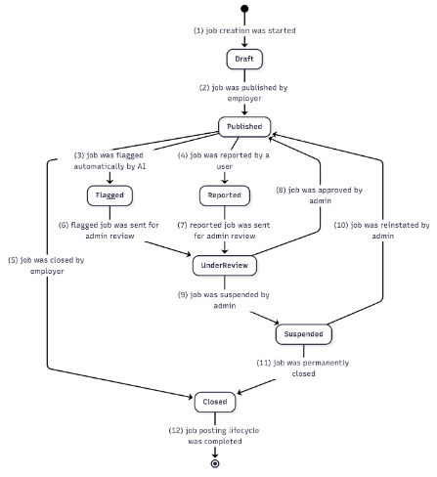

4.9.2 Application Lifecycle
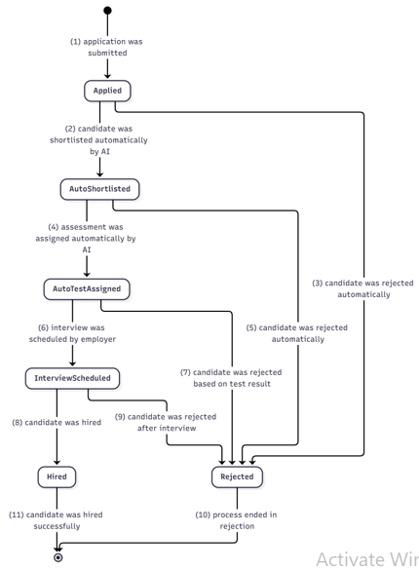

4.9.3 Assessment Lifecycle
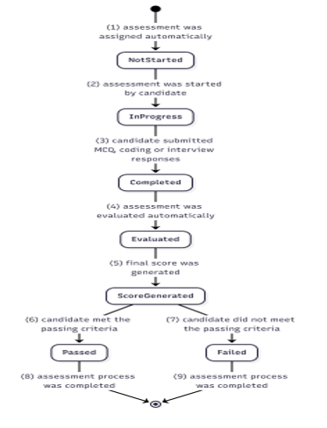

4.9.4 Interview Lifecycle
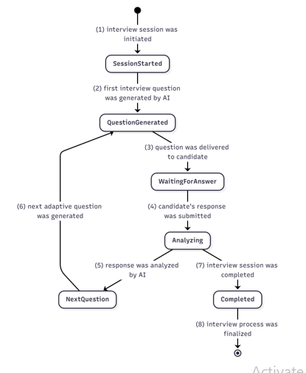

4.10 Workflow Visualizations (Sequence Diagram)

4.10.1 Authentication Workflow
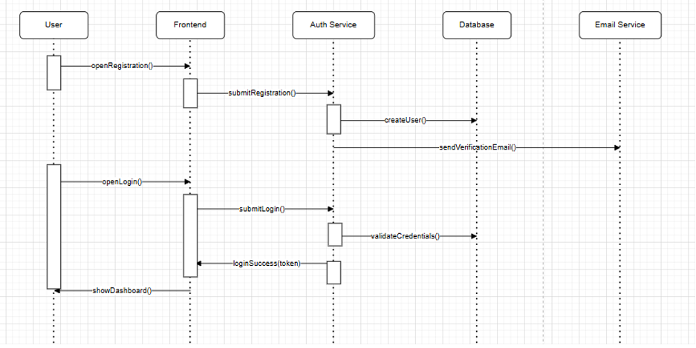

4.10.2 Resume Parsing Workflow
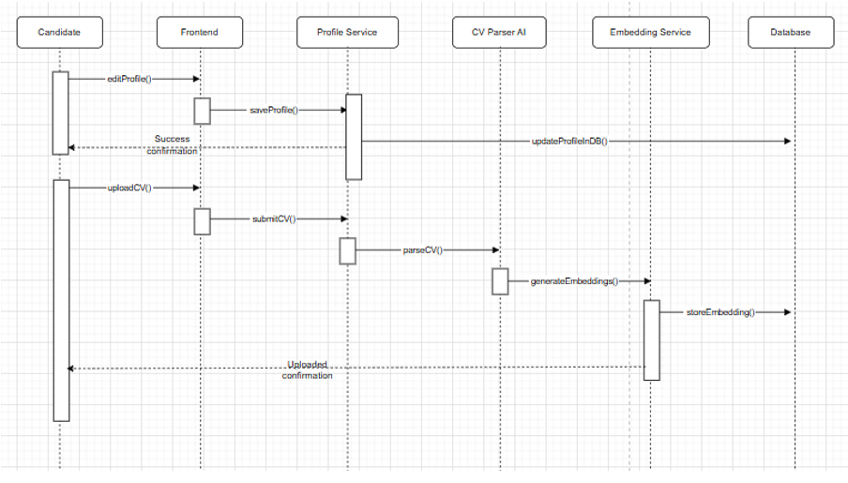

4.10.3 Job Application Workflow
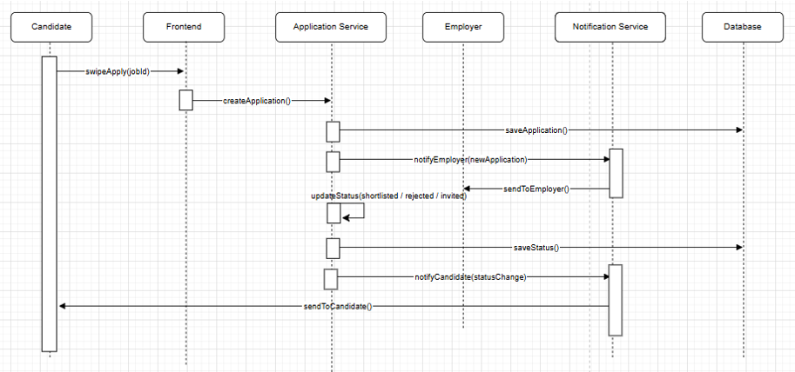

4.10.4 Candidate Ranking Workflow
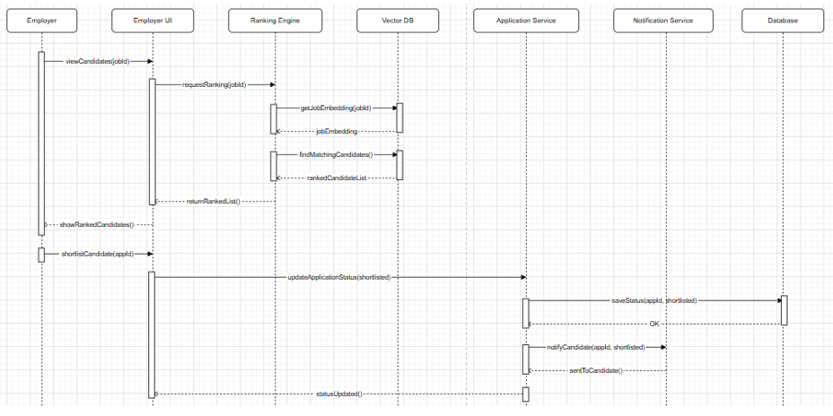

4.10.5 AI Interview Workflow
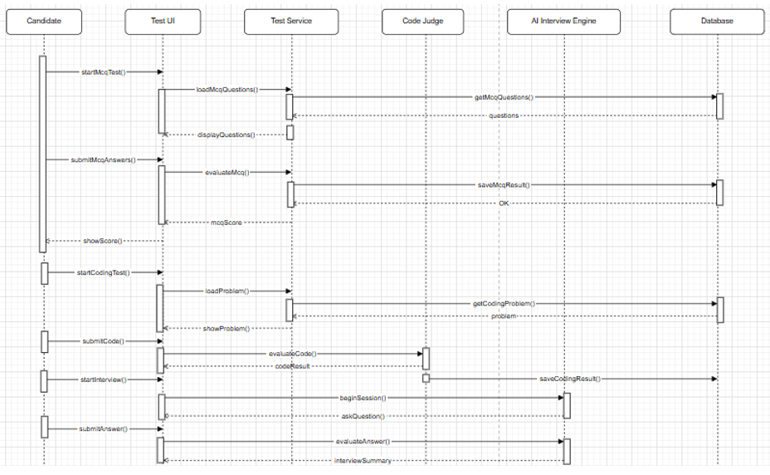

4.10.6 Fraud Detection Workflow
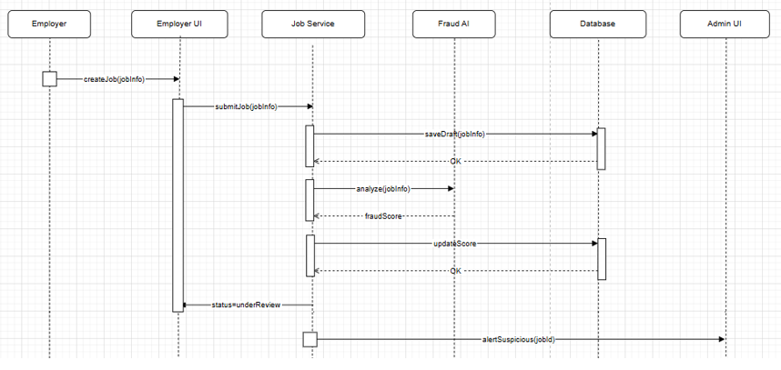

5. Implementation

5.1 FYP-I Implementation
During FYP-I, the foundation of CareerForge was developed. The team focused on building the main architecture, implementing core modules, and integrating the frontend, backend, database, vector search, and AI services. The frontend was developed using React.js and Tailwind CSS, while the backend was built using FastAPI with a modular structure consisting of routes, controllers, services, middleware, and utility modules.
The major modules completed during FYP-I included fake job detection, job-description enhancement, resume parsing, and JD-CV matching. Supabase was integrated for authentication, PostgreSQL database management, and resume storage. Pinecone was integrated for storing and retrieving embeddings used in semantic search and candidate-job matching. Core APIs were implemented for authentication, user onboarding, resume upload, resume parsing, job posting, job search, fraud detection invocation, and semantic matching.
Manual testing during FYP-I confirmed that the foundational workflows were functioning together, including user onboarding, job posting, resume parsing, candidate ranking, and moderation support. The fake job detection model showed strong classification performance during evaluation, while the JD enhancer successfully refined unclear or biased job descriptions into clearer and more professional versions.

5.2 FYP-II Implementation
In FYP-II, CareerForge was extended with a complete candidate screening pipeline and end-to-end workflow integration. The main objective was to move the platform beyond basic job posting and application submission by adding a structured multi-stage evaluation process for each job application. This allowed employers to review candidates using measurable performance data instead of relying only on resumes or manual screening.
The FYP-II implementation included assessment creation and retrieval, candidate test attempts, response submission, grading, and result storage. Each job application is connected to its assessment stages through a common application identifier. This ensures that MCQ scores, technical submissions, interview transcripts, AI feedback, grading outputs, and final evaluation results remain associated with the correct candidate and job. The assessment workflow follows a clear process in which the candidate applies for a job, the backend creates an application record, assessment stages are attached to the application, the candidate attempts the assessments through the frontend, and responses are submitted and stored in the database.
The MCQ module supports both AI-assisted question generation and automatic grading. Relevant technical context is retrieved using Tavily based on the job description and required skills. This context is passed to an AI agent, which generates structured MCQs containing the question statement, answer options, and correct answer. These questions are stored in the database and served to candidates during the assessment. Once submitted, candidate responses are compared with the stored correct answers, scores are calculated instantly, and results are saved against the candidate’s test attempt.
The technical test module focuses on coding problems and short conceptual questions. Tavily is used to gather relevant context related to programming topics, tools, and job requirements. An AI agent then generates coding problem statements, constraints, and expected logic. When the candidate submits an answer, the backend evaluates the solution using an evaluator agent, and the result is stored against the candidate’s application. The updated database design supports this workflow by storing technical questions, rubrics, model solutions, candidate answer text, AI score, feedback, grading model, prompt version, grading confidence, and language information. The interview module works as a response-evaluation component. Audio is captured using WebRTC and converted into a transcript through speech-to-text processing. The transcript is cleaned and passed to an AI agent for evaluation. The evaluation focuses on relevance, technical accuracy, clarity, coherence, and depth of explanation. The output includes a numerical score, strengths and weaknesses, and a brief summary. Unlike the MCQ and technical modules, Tavily is not used in this module because the purpose is to evaluate candidate responses rather than generate assessment content.
FYP-II also included the swipe-to-apply feature and complete workflow integration. Swipe-to-apply allows candidates to quickly apply to or skip job opportunities, while the backend directly creates the corresponding application record through APIs. The integrated system now connects the complete workflow from employer job posting to candidate application, assessment assignment, test attempt, AI-assisted grading, result storage, and employer review. The complete system flow includes employer job posting, candidate search and application, application storage, screening pipeline activation, MCQ assessment, technical test, interview evaluation, result storage, and employer review of candidate performance. The modules listed as remaining work during the FYP-II progress stage were completed in the final phase. The admin dashboard frontend was integrated with the existing backend APIs for user management, job moderation, and system control. The skill-gap analyzer was connected with the overall system so that candidates can compare their current skills with job requirements and receive improvement guidance. The notification system was completed through database-level notification records and user-facing alerts for important system events such as applications and assessment updates. The career recommendation engine was also finalized to provide candidates with personalized job and career suggestions based on their profile data and system intelligence.
Overall, FYP-II transformed CareerForge into a fully integrated AI-powered recruitment platform. The system now supports job posting, resume-based matching, candidate applications, MCQ assessment, technical evaluation, AI interview analysis, skill-gap guidance, career recommendations, notifications, admin moderation, and employer-side performance review. This makes the platform more than a traditional job portal, as it provides a complete intelligent recruitment workflow tailored to the Computer Science and IT domain.

6. Testing and Evaluation
Testing for CareerForge focused on verifying both individual modules and the end-to-end recruitment workflow. Since the system combines frontend interfaces, backend APIs, Supabase, Pinecone, and AI services, testing was performed manually and functionally across the major workflows to confirm that components interacted correctly.
During FYP-I, manual functional testing confirmed that authentication, job posting, resume upload, resume parsing, candidate ranking, and moderation-related workflows operated without critical issues. The fake job detection model was evaluated using standard machine learning metrics. Reported results showed strong performance, with high accuracy, precision, recall, and F1-score during model evaluation. The JD enhancer was also tested by submitting job descriptions and reviewing whether the output improved clarity and reduced unclear or biased wording.
During FYP-II, testing focused on the candidate screening pipeline. The MCQ assessment flow was tested by generating or storing questions, loading them on the frontend, submitting candidate answers, and verifying that scores were calculated and stored. The technical test flow was tested by storing questions, submitting answers, and checking that AI score, feedback, and grading metadata were saved correctly. The interview workflow was tested by capturing or processing candidate responses, storing transcripts, and generating AI-based evaluation outputs such as score, strengths, weaknesses, and summary.
End-to-end workflow testing was also performed to ensure that the application lifecycle remained consistent. The tested flow included employer job posting, candidate application, assessment creation, candidate attempt submission, result storage, and employer access to candidate performance. Database testing focused on foreign-key relationships, application-linked assessment data, and correct association between candidates, jobs, resumes, attempts, answers, submissions, and transcripts.
Overall, the testing confirmed that the core CareerForge modules and integrations functioned as intended. The platform successfully demonstrates the main project idea: an AI-supported recruitment ecosystem that combines trust, matching, screening, and candidate evaluation in one system.

7. Conclusion
CareerForge was developed as an AI-powered recruitment platform for the Computer Science and Information Technology job market. The project addresses key limitations of traditional job portals, including fraudulent job postings, inefficient candidate screening, poor job-candidate matching, vague job descriptions, and lack of career guidance for candidates.
During FYP-I, the project established its core technical foundation by implementing the frontend, backend, database integration, authentication, resume parsing, fake job detection, JD enhancement, and semantic matching. During FYP-II, the project moved toward a complete candidate screening pipeline by integrating MCQ assessments, technical test support, AI-assisted interview evaluation, test attempts, grading records, transcripts, and end-to-end workflow connectivity.
The final design is supported by a modular architecture, an updated relational database schema, and AI service integration. The system gives candidates a structured way to apply and improve their career direction, gives employers tools to evaluate applicants more efficiently, and gives administrators moderation support to improve platform trust. By combining automation, AI assistance, and role-based recruitment workflows, CareerForge provides a strong foundation for a specialized, intelligent, and scalable recruitment platform for the Pakistani CS/IT ecosystem.

8. Generative AI Usage Statement
During the development of CareerForge, Generative AI tools, including ChatGPT and Gemini, were used as supportive resources at different stages of the project. These tools assisted in refining documentation, organizing report content, improving the clarity of technical explanations, and enhancing the overall presentation of written material. ChatGPT was also used for general coding guidance during the development process.
The use of Generative AI was limited to assistance, guidance, and refinement. The project idea, system design, implementation decisions, testing, analysis, and final validation were carried out by the project team. All AI-assisted content and suggestions were reviewed, verified, and modified by the group members to ensure that the final submitted work reflects the team’s own understanding, effort, and project outcomes.

9. References
[1] LinkedIn, “About LinkedIn,” 2025. [Online]. Available: https://about.linkedin.com.
[2] Indeed, “About Indeed,” 2025. [Online]. Available: https://www.indeed.com/about.
[3] Rozee.pk, “About Rozee,” 2025. [Online]. Available: https://www.rozee.pk/company/rozeepk/about.
[4] J. M. and R. W. Y. Li, “Deep Learning for Job Resume Matching: A Survey,” IEEE Access, vol. 8, pp. 137-151, 2020.
[5] A. M. and A. K. D. S. Chakraborty, “An Approach to Detect Fake Job Postings using Natural Language Processing,” International Journal of Engineering and Advanced Technology, vol. 9, no. 3, 2020.
[6] J. F. and A. C. K. A. Gaucher, “Evidence That Gendered Wording in Job Advertisements Exists and Sustains Gender Inequality,” Journal of Personality and Social Psychology, vol. 101, no. 1, pp. 109-128, 2011.
[7] Google, “Google Generative AI Documentation.” [Online]. Available: https://ai.google.dev.
[8] Tavily, “Tavily Search API Documentation.” [Online]. Available: https://tavily.com.
[9] WebRTC, “WebRTC Documentation.” [Online]. Available: https://webrtc.org.
[10] FastAPI, “FastAPI Documentation.” [Online]. Available: https://fastapi.tiangolo.com.
[11] Supabase, “Supabase Documentation.” [Online]. Available: https://supabase.com/docs.
[12] Pinecone, “Pinecone Documentation.” [Online]. Available: https://www.pinecone.io.

